Know the types of matter and be able to sort the types of matter using definitions or images.
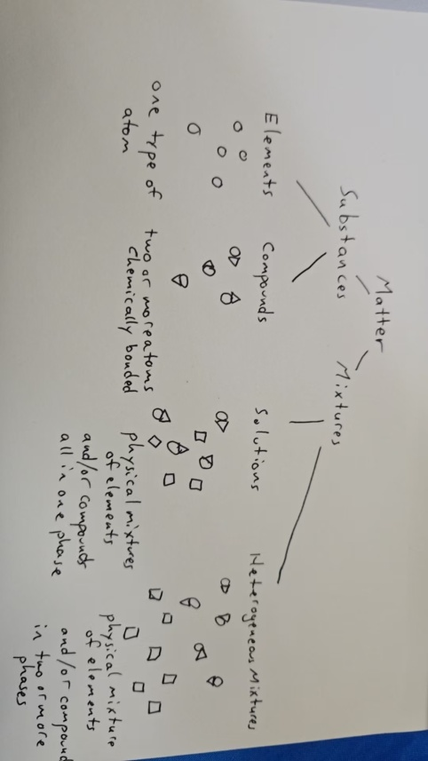
Elements are the simplest form of matter with unique properties. Compounds are two or more atoms bonded chemically. Solutions are uniform mixtures – two or more elements and/or compounds in one phase. Heterogeneous mixtures are non-uniform mixtures – two or more elements and/or compounds in two or more phases.
Atoms are the smallest particle of an element, and it still has its chemical identity. Protons are large positively charged particles that exist in the nucleus of an atom. Neutrons are large neutral particles that exist in the nucleus of an atom. Electrons are tiny negatively charged particles that move around the nucleus.
1A metals are the alkali metals. 2A metals are the alkaline earth metals. Group B metals are transition metals. Metalloids are elements with properties of both metals and nonmetals.
Ions are atoms with a different number of electrons. Isotopes are atoms with a different number of neutrons. Noble gases have filled s and p orbitals and are very stable; they do not easily react.
Rutherford’s atomic model showed electrons moving around a nucleus in set circular orbits, like planets around the sun. Bohr’s model builds on Rutherford’s model by adding multiple paths for the electrons, called energy levels. Schrödinger’s model (the quantum mechanical model) shows the probability of finding electrons around the nucleus of an atom.
Heisenberg’s uncertainty principle suggests that we can know either the position of an electron around the nucleus or the velocity of an electron, but we cannot know both.
Ionic compounds form when one atom steals electrons from another, and the difference in charges attract each other.
Mass is the amount of matter that exists in a sample. Volume is the amount of space matter takes up. Accuracy is the measure of how close an answer is to a correct answer. Precision is the measure of how close various measurements are to each other. A quantum is a set amount or set package of energy.
Be comfortable finding the ionic charges for elements (+1 for group 1, +2 for group 2, +3 for group 13, -3 for group 15, -2 for group 16, and -1 for group 17).
Be able to write numbers in scientific notation (a * 10^{b}).
Be able to use number prefixes.
Be able to use the equations as light (c=λυ, E=hυ).
Be able to write electron configurations for elements.
Know the shapes for atomic orbitals.
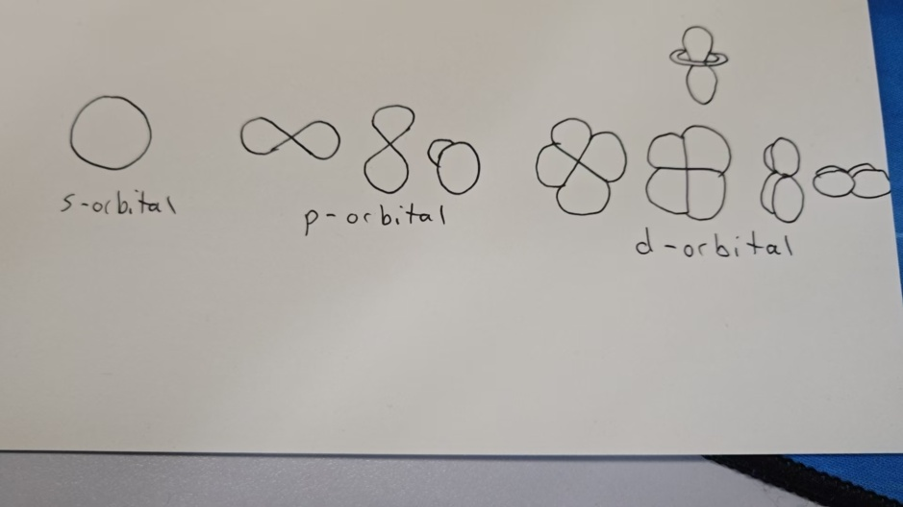
Dalton discovered the atom. Thomson discovered the electron. Goldstein discovered the proton. Chadwick discovered the neutron. Rutherford discovered the nucleus.
Dalton said that everything is made of atoms, which are invisible and indestructible balls. Atoms of one element should always be the same, and atoms of different elements should always be different. Atoms can be physically mixes or chemically mixed. Reactions can create compounds, break compounds, or mix atoms in compounds.

